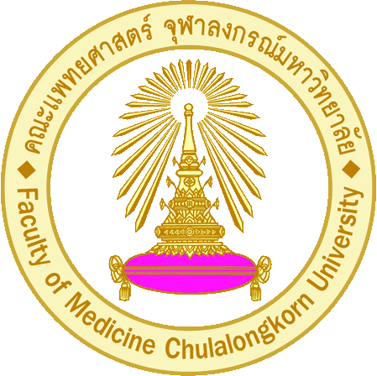
APPLICATION FOR ADMISSION
Application I.D. Number (office only)
2013/________
4th International Workshop on “Protein Expression

Photo
1” x 1”
and purification Technology”
(28 Oct 2013 - 1 Nov 2013)
Faculty of Medicine, Chulalongkorn University
Bangkok 10330, Thailand

Instruction: Please fill out this form in CAPITAL LETTERS and make your selection by marking an “X” in below.

I. Personal Information

Title: Mr. Mrs. Miss Other:

Name (in English):
(FIRST NAME) (MIDDLE NAME) (LAST NAME)

Identification Number: - - -

Passport Number: Expiration Date (DD/MM/YYYY): / /

Date of Birth (DD/MM/YYYY): / / Age: Gender: Male Female
Nationality: Religion: Marital status: Single Married Divorced

Mailing Address:
(STREET ADDRESS) (CITY)

Phone: Fax:
(STATE) (ZIP CODE) (COUNTRY)
Mobile Phone: Email:
II. Education:
College/University | Degree | Field/Branch | Year Completed

III. Language/Ability: Your Mother Tongue is
English Proficiency:
Understand | Speak | Read | Write

IV. Current Employment:
Period: Position:
Organization / Institution:
Mailing Address:
(STREET ADDRESS) (CITY)

Phone: Fax:
(STATE) (ZIP CODE) (COUNTRY)
V. Enrollment Fee:
Full Workshop (Lecture + Lab) after 31 August 2013 10,000 Baht
Lecture only 1,000 Baht
Early bird: (Lecture + Lab) until 31 August 2013 8,000 Baht
VI. Mode of Payment:
- By Cash: Please pay the enrollment fee at
Division of Research Affairs, 7th Floor, Aor – Por - Ror Building, Faculty of Medicine, Chulalongkorn University, Rama 4, Bangkok 10330 Tel: 02-256-4455, 02-256-4000 ต่อ 3547 Fax: 02-251-6706
มือถือ 090-1069557 , 089-4962727
- Bank Transfer: Please transfer the enrollment fee to
A/C NAME: INTERNATIONAL WORKSHOP A/C NO: 045-548604-7
SWIFT CODE: SICOTHBK THE SIAM COMMERCIAL BANK PLC SAPHA KACHAT THAI BRANCH
ADDRESS: 1873 HENRY DO NANT RD. PATHUMWAN, BANGKOK. 10330 THAILAND
*Attendants are responsible for paying all bank transfer charges. Please select “Pay in full” option.
ชื่อบัญชี International workshop เลขที่บัญชี 045-548604-7 ธนาคารไทยพาณิชย์ จำกัด (มหาชน) สาขาสภากาชาดไทย
VII. Documents Required with Application
- Application form with 1x1 inch photo
- Copy of passport (for international applicants)
(For copied documents, please sign each document certifying that it is a true copy.)

I certify that all documents submitted are correct

Signature
( )
Date (dd/mm/yyyy):

Please submit your application package and payment evidence via email: smedsuk@md.chula.ac.th

